Happy Holidays
No Homework Assignment
For the Week of Dec. 16th – 19th
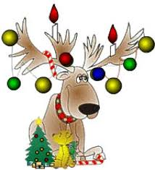
Enjoy,
Mrs. Hamrick-Moravec

